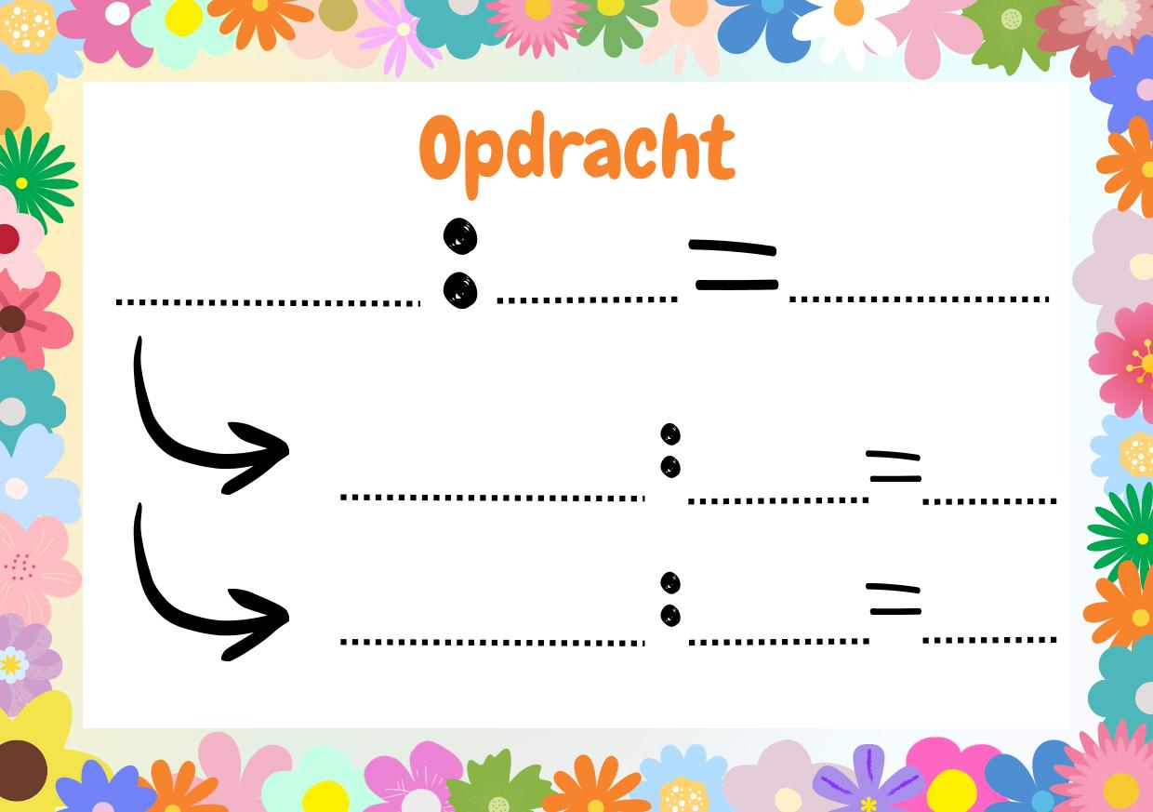

99
9999

99

99

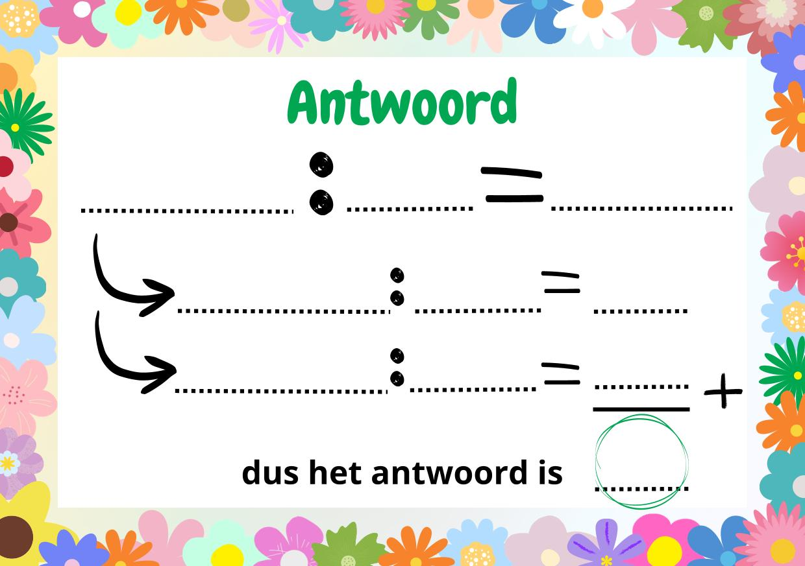
99
99
99
9999
9999
99
99
99
9999

